

# MODULE 1

In this section we will:

* Describe browser problems
* Explain advantages of mobile devices
* Discuss the advantages and disadvantages of video conferencing.

We will cover these grammar points: present simple vs present continuous, zero, first and second conditionals.

*Let’s start!*

# Class 1: Internet browsing

This section looks at internet browsers and web addresses. While the terms **the internet** and **the World Wide Web** (usually shortened to ‘the web’) are often used interchangeably, but there is actually a significant difference.

## SPEAKING

**Work in pairs. Discuss these questions.**

1. Which websites do you visit most often?
2. Which browsers do you use? Which is your favorite? Why’
3. What kind(s) of device(s) do you use to access the internet?



## VOCABULARY

**Match these words to A-F in the screenshot of a browser below.**

1 web address ___ 4 tab ___ 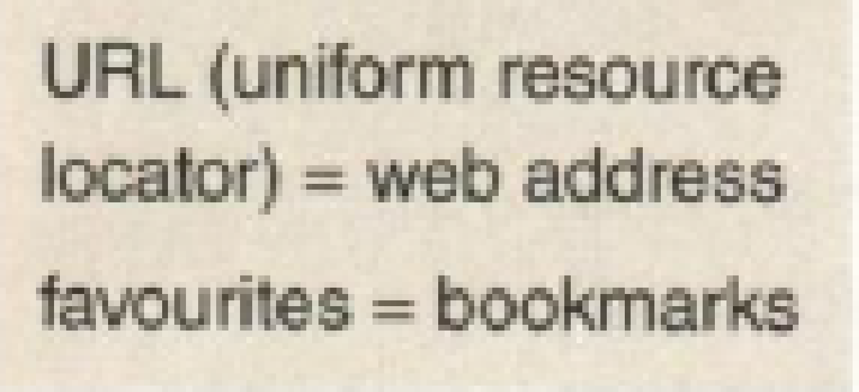

2 bookmarks bar ___ 5 link ___

3 ‘back’ button ____ 6 ‘refresh’ button ___

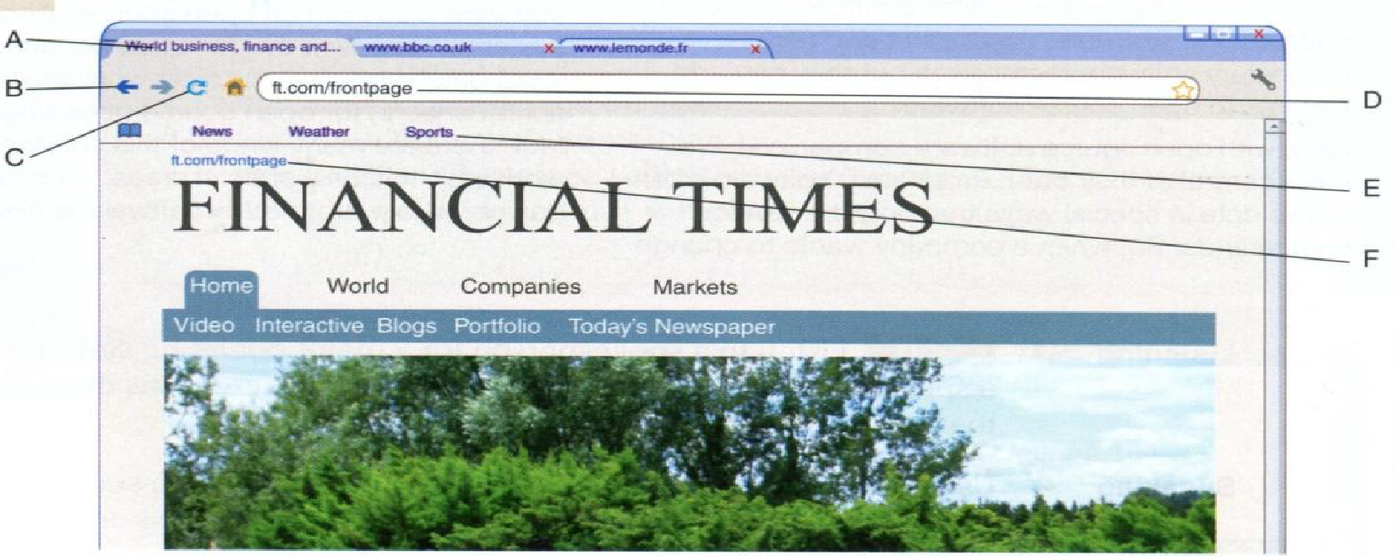

1. **Match the verbs 1-8 to nouns a-h to make collocations for things you can do on the internet. For some items there may be more than one possible answer.**

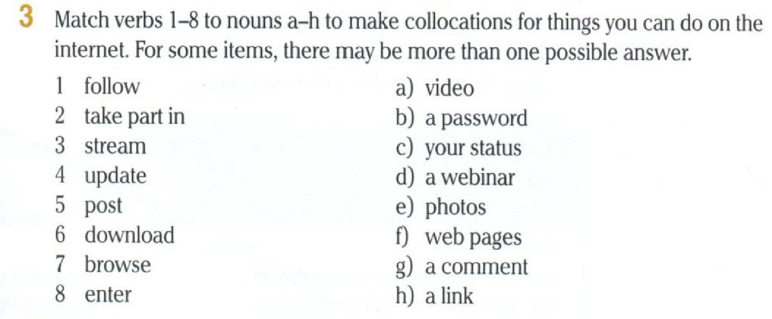



## WRITING

**What do you do on the internet? Write five sentences using the collocations in exercise 3.**



## LISTENING

[**Listen**](https://drive.google.com/file/d/1tB7QsA92IXP-q9_HZKGDVpHrTRQ-3UGl/view?usp=sharing) **to an admin assistant telephoning and IT specialist about a new browser. Does the IT specialist solve his problem? What does the admin assistant like about the new browser?**

1. **Listen again. What three things does the admin assistant need help with?**

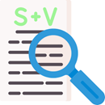

## LANGUAGE

**Present simple vs present continuous, stative verbs.**

| We use the present simple to talk about something we do regularly. We use the **present** continuous to talk about an action happening now or *a* temporary situation. | *I* ***work*** *in an IT Department. This week I'm managing the department because my manager is away.* |
| --- | --- |
| **Stative verbs** (e.g. *like, know, understand)* describe states rather than actions. We don't usually use the present continuous with stative verbs. | *I* ***know*** *how to* use *HTML.* |



1. **Underline the present simple and circle the present continuous verbs in these sentences from 5. Why did the speaker use the tense in each case?**
   1. *I'm having trouble with the new browser we're using on our PCs.*
   2. *I understand that now. But something else is confusing me.*
2. **Complete this telephone conversation between an IT help desk assistant and an employee. Use the correct present simple or present continuous form of the verbs in the box.**



A: There's a problem with this browser. I usually just (I) _____ my user ID and password and a new window (2) ______ .But it (3) _______ now!

B: OK, I think I (4) _______ what the problem is. Probably your pop-up blocker is on.

A: Hmm ... I (5) ____ it now. Yep, you're right. It's OK now. Thanks!

## SPEAKING

**9. Roleplay telephone conversations for these situations. Take turns being the IT help desk assistant and the caller. Use the conversation in 8 as a model.**

a. problem: video streaming/usually no problem/now not work solution: internet connection problem/check the connection

1. problem: website images/usually all appear/now no pictures solution: leave 'Automatically load images' unchecked
2. problem: often visit this website/now error message solution: enter 'www' in the web address, not 'wwww'

LISTENING **(**track 13)

**10.** [**Listen**](https://drive.google.com/file/d/1FWnBLBop56RNxNlzCUgWHevFAptxi2kq/view?usp=sharing) **to part of a telephone conversation. Complete 1-5 with the correct symbols from the web address the speaker dictates.**

[www.d-o-socialwork.gov.ae/schools_2.html?72](http://www.d-o-socialwork.gov.ae/schools_2.html?72)

1 dash__ 3 slash __ 5 question mark __

2 dot__ 4 underscore __

**11.** [**Listen**](https://drive.google.com/file/d/1-tGB_LlpvT9QUi-UyNw6WSPR-ZSARwLL/view?usp=sharing) **to part of a telephone conversation. Which web address does the speaker dictate?**

1. [www.agamy.com/search/results_78.aspx?p](http://www.agamy.com/search/results_78.aspx?p)
2. [www.agamy.com/search/results/78.aspx-p](http://www.agamy.com/search/results/78.aspx-p)
3. [www.agamy.com/search/results_78.aspx-p](http://www.agamy.com/search/results_78.aspx-p)

SPEAKING: Internet browsing

**12. Work in pairs.**

* Student A, look at the following information.

Read these web addresses to Student B. Then listen and write down the web addresses Student B reads to you.

1. [www.w-3.org](http://www.w-3.org/)
2. [www.aceinfo.net.au/about](http://www.aceinfo.net.au/about)
3. [www.basic-comp.eo.jp/forum/l_754](http://www.basic-comp.eo.jp/forum/l_754)

* Student B, look at the information on page 70. Follow the instructions.

Listen and write down the web addresses Student A reads to you. Then read these web addresses to Student A.

1. [www.worldbox.com.sa](http://www.worldbox.com.sa)
2. [www.internode.net.de/business_intro](http://www.internode.net.de/business_intro)
3. [www.ug.edu/study/program.html?prog=2236](http://www.ug.edu/study/program.html?prog=2236)

**Complete the following sentences using the correct form of the verbs given. Present simple or continuous.?**

1. Every afternoon, the students __________ (practice) coding skills in the lab.
2. Right now, Pablo ________ (work) on a project that uses artificial intelligence.
3. Pam usually _________ (take) online courses to improve his programming knowledge.
4. They ____________ (not understand) the new programming language we introduced last week.
5. At the moment, we ___________ (discuss) various software development methodologies.
6. Kiara often ___________ (help) her classmates with their coding assignments.

For **extra practice**: check the web page below: 

<https://www.liveworksheets.com/w/en/english-second-language-esl/1380240>

# Class 2: MOBILE COMPUTING

This section looks at mobile devices such as mobile phones and tablets (iPad and similar), and custom devicessuch as those that traffic wardens, train conductors and courier company drivers use.

## SPEAKING

1. **Work in small groups. What features do you use on a mobile device (e.g. GPS,**

**maps, camera)? What do you use them for?**

1. **Work in pairs. Think about people in these jobs. How might a mobile device be useful to them?**
   1. company salesperson who visits many client companies
   2. a delivery driver for a parcel delivery company
   3. a technician who installs entertainment systems in people's homes
2. **Complete the flowchart with steps a-f in the correct order.**
3. admin staff print out work instructions
4. admin staff send invoice asking for payment
5. client signs paperwork
6. technician finds client and installs system
7. technician picks up instructions
8. technician takes paperwork back to office

**Entertainment systems installation workflow**



1. **Work in pairs. How do you think the workflow in 3 will change if the technician has a mobile device? Draw a new flowchart and complete the stages.**

1. [**Listen**](https://drive.google.com/file/d/1qYyYGUFVf5AGt7_XSAKnN_X3biYTgcqk/view?usp=sharing) **to an IT specialist talking to a high-level manager, explaining how their entertainment system installation technicians can use new tablet computers. Check your answers in 3 and 4.**

## LANGUAGE: Conditionals 0 and 1

| We use **the zero** conditional to talk about something that usually or always happens **as a result of an action or situation**. | ***If*** *you* ***drop*** *a tablet, it* ***breaks.***  ***If*** *you* ***use*** *a tablet, you* ***can send*** *documents* easily. |
| --- | --- |
| We use **the first conditional** to talk about the **result of a future action or situation.** | ***If*** *we* ***have*** *a problem****, we'll send*** *a* message**.** |
| We use **a comma between** the **two clauses** when the ***if-clause* comes first** but not when it comes last. | ***If*** *we buy tablets****, we'll save*** *money. We'll* save *money if we buy tablets.* |

1. **The company in 5 is now using the tablets. Complete these zero conditional**

**sentences.**

* 1. With the tablets, if the technician (not know) ……………………… the way to a job, he or she (use) ………………. GPS to find the best way there.
  2. If the customer (be) ……………. happy with the job, he or she (sign) ………………………. using the tablet's screen.
  3. If a customer (change) …………………….. their order, the system (update) …………………... the details on the tablet.
  4. If a technician (need) …………………… to order a new part, he or she (send) ……………………… a message electronically.

1. **Work in pairs. Look at the flowcharts in 3 and 4. Describe how *efficiency* and**

***flexibility* will improve if the company uses tablets.**

*Important note:* ***efficiency*** *is improved when the same work can be done in less time or by fewer people, and* ***flexibility*** *is improved when it is easy to change decisions or do things in a different way.*

**Look at audio script 16 (exercise 5) and check your answers**.

1. **Work in pairs. How are these mobile device features and functions useful?**



Example: *If the phone has a GPS, we can use it to find places. If the battery life is long,* ...

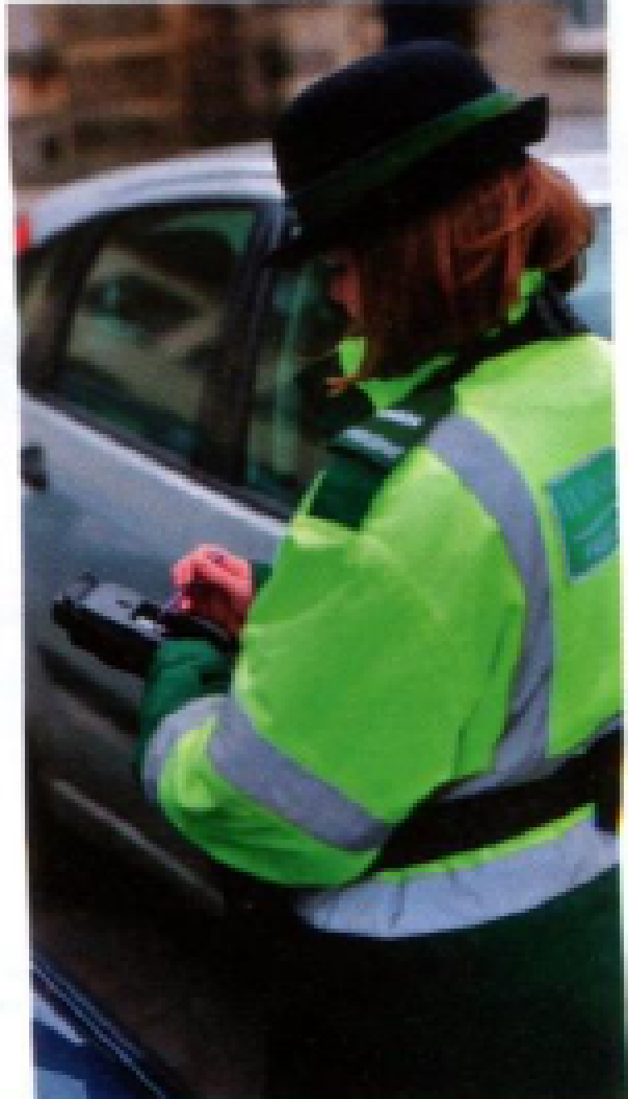

1. **Work in pairs. What is the person in the photo doing?**

**What is her job?**

**How might a mobile device help her in her job?**

## GRAMMAR PRACTICE

**Complete the following sentences using the correct Conditional tense (T0 or T1)**

1. If the new software is developed in Canada, the company __________(save) US$59,000.  (T1)
2. If you regularly _________(film) videos, then you will want as big a hard drive as you can get. (T1)
3. If your hard drive ___________ (become) 85 percent full, it’s going to affect your computer’s speed.(T1)
4. We ___________ (not be) able to watch the movie if the computer program is not compatible. (T1)
5. If you __________ (be) interested in data solutions, we can help you. (T0)
6. If the user ____________(submit) a form, the information is sent back to a specific page. (T0)
7. Your computer __________ (be) faster if you have enough memory. (T1)
8. If you use antivirus software, the user interface (UI) of cloud antivirus software __________ (look)  familiar. (T1)
9. If you _____________(have) ambitions of becoming a web developer, PHP could be the best language to learn. (T1)

1. **Read the advertisement and find words in the text that match these definitions.**

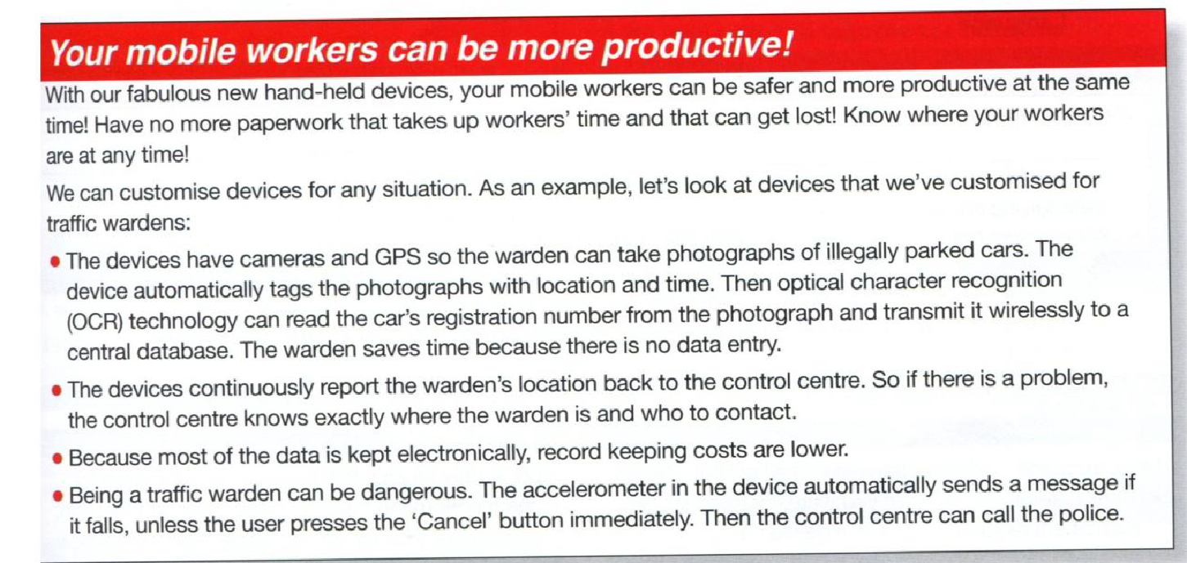

1. change something to make it suit a special purpose .___
2. add electronic information to something, e.g. a photo _
3. the position of something _
4. changing written or printed words to data that a computer can understand _
5. give information _
6. a word used to show that something is completely correct and true _
7. stored information, e.g. on a computer _

**Work in small groups. You are technicians in the mobile device company in 10. Suggest how and why you could customize mobile devices for these jobs.**

1 delivery driver 2 salesperson 3 nurse

Example: *A CPS will be very useful for a delivery driver. If he or she gets lost, it'll help him or her to find his or her customers.*

**Extra practice: check these webpages**

Conditional 0: <https://www.liveworksheets.com/w/en/english-second-language-esl/44661>

Conditional 1: <https://www.liveworksheets.com/w/en/english-second-language-esl/44705>

Conditional 0 and 1: <https://www.liveworksheets.com/w/en/english-language/1628073>

# Class 3: TRADUCCIÓN DE ORACIONES CONDICIONALES

Las oraciones condicionales son también conocidas como cláusulas **‘If’** y tienen la siguiente forma:

Las cláusulas condicionales se comportan prácticamente del mismo modo en español y en inglés. La cláusula condicional propone una acción que provocará que otra ocurra. El sentido de cada oración varía dependiendo de los tiempos verbales que se utilicen.

Los condicionales son un tipo de oraciones muy útiles para plantear escenarios que van desde los reales hasta los imaginarios. Por ello, suelen relacionarse con planes, deseos, sueños o propósitos. El sentido de cada oración varía dependiendo de los tiempos verbales que se utilicen.

### 1. CONDICIONAL 0

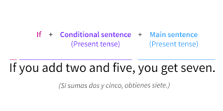

Esta estructura expresa que una acción se desprende automáticamente de otra. Denota una condición real que tiene un resultado inevitable. Un claro ejemplo de este tipo de oraciones son las relacionadas con argumentos científicos.

**Este tipo de condicionales se utiliza para:**

1. **Para hablar de una verdad irrebatible:**

If you don’t sleep, you are tired. (Si no duermes, estás cansado)

1. **Para hablar de hechos demostrables a través de la ciencia:**

If you put water in the freezer, it freezes. (Si pones agua en el congelador, se congela)

**El condicional 0 puede utilizar *when* (cuando) en lugar de *if* cuando el significado de la oración es “cada vez que.”**

* You can’t use this program if the computer is not updated.
* When I turn on the computer, a strange window pops up.

**Estructura:** 

### 2. CONDICIONAL 1

Esta construcción condicional se utiliza para expresar *posibilidad y certeza* / *certeza y posibilidad*. Aquí una acción será completada si la otra acción se lleva a cabo.

Dicho de otro modo, se utiliza para plantear escenarios en el futuro cuya realización es muy probable. Por este motivo, se utiliza para expresar planes.

Lee los siguientes ejemplos con atención. ¿Cómo podrías traducirlos?

* The computer will shut down if you press that button.
* If the new staff doesn’t handle the new software, they will be dismissed next year.

**Estructura:**



***Nota:*** *También se puede formar este condicional usando algunos verbos modales en lugar de will, tales como: may, should, can, could.*

**Ejemplos:**

**If everyone agrees, we will go to Spain next year** (Sí todos están de acuerdo, vamos a España el próximo año).

**We may buy it if we like the computer.** (La podríamos comprar si nos gusta la computadora).

## PrácticaPractice - Free education icons

**Traduce las siguientes oraciones.**

1. If the new software is developed in Canada, the company will save US$59,000.
2. If you regularly film videos, then you will want as big a hard drive as you can get.
3. If your hard drive becomes 85 per cent full, it’s going to affect your computer’s speed.
4. We won’t be able to watch the movie if the computer program is not compatible.
5. If you are interested in data solutions, we can help you.
6. If the user submits a form, the information is sent back to a specific page.
7. Your computer will be faster if you have enough memory.
8. If you use antivirus software, the user interface (UI) of cloud antivirus software will look familiar.
9. If you have ambitions of becoming a web developer, PHP could be the best language to learn.

Fuentes consultadas:

Hill, David. (2012). English for Information Technology 2 . Pearson Education.

<https://www.aprenderinglesrapidoyfacil.com/2014/01/27/condicional-cero-0-en-ingles-con-ejemplos-zero-conditional/>

<https://www.aprenderinglesrapidoyfacil.com/2014/04/22/primer-condicional-ingles-explicacion-first-conditional/>

<https://www.britishcouncil.org.mx/blog/conditionals#:~:text=Estructura%20gramatical%20del%20first%20conditional,verbo%20conjugado%20en%20present%20simple>

<https://oxfordhousebcn.com/en/4-conditionals-in-english-and-when-to-use-them/>

<https://trucoslondres.com/?s=condicional+1>

# Class 4: VIDEO CONFERENCING

Video conferencing can be a great time and money saver for business as it can avoid the need to travel. However, equipment can be expensive and often a dedicated room (sometimes called a telepresence room) is necessary.

Let's talk about the advantages and disadvantages of visual as opposed to audio-only communication.

## SPEAKING

**1. Work in pairs. Discuss these questions.**

a. Which method of communicating do you prefer: face-to-face, by video or by telephone?

b. Look at the photo. Have you ever used a video conferencing set-up? If so, describe the situation.

c. What do you think are the advantages of video conferencing over face-to-face meetings?

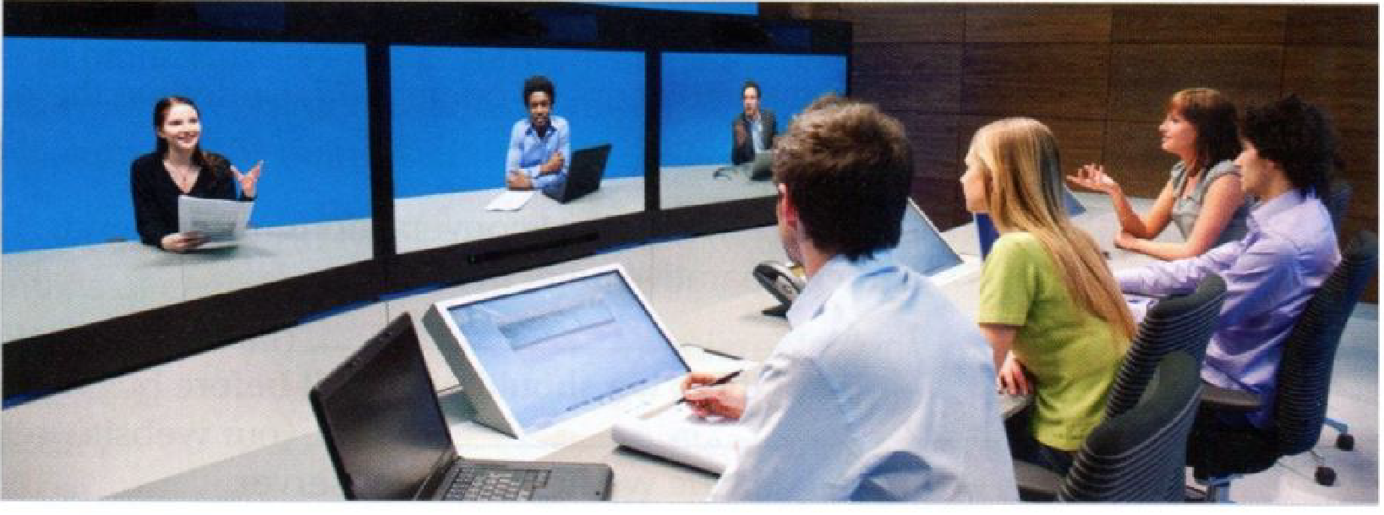

**2. Which of these items can you see in the photo? Mark the items on the photo.**



**3.** [**Listen**](https://drive.google.com/file/d/1ZsZHxInTDMuyKHWYq9DHK8l-zbPV6kvH/view?usp=sharing) **to two technicians talking about video conferencing technology. Which two types of system does the woman talk about?**

1. **Complete these glossary definitions with the words in the box.** 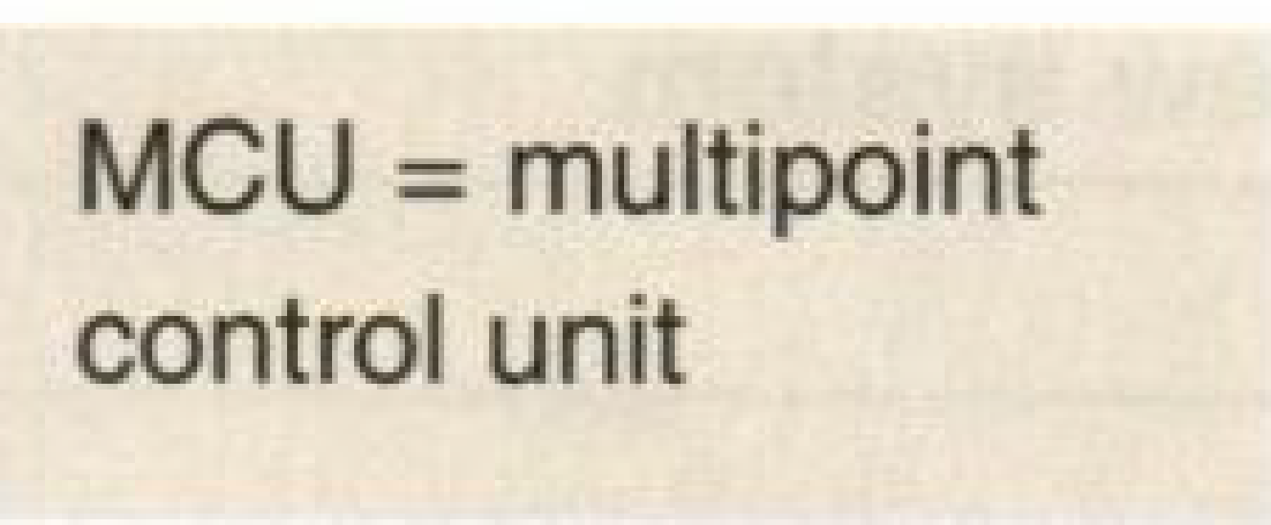

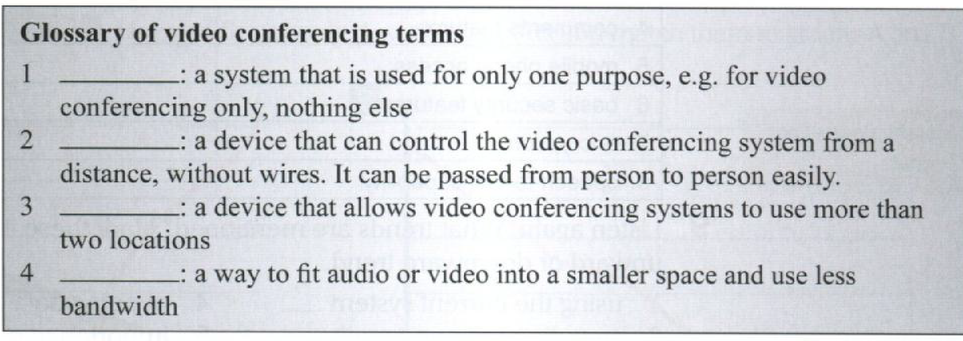

## LANGUAGE: Conditional 2

## Second conditional

**5. Look at audio script 32 and underline all the examples of the second conditional. Which tense do we use in the *if* clause? In the main clause?**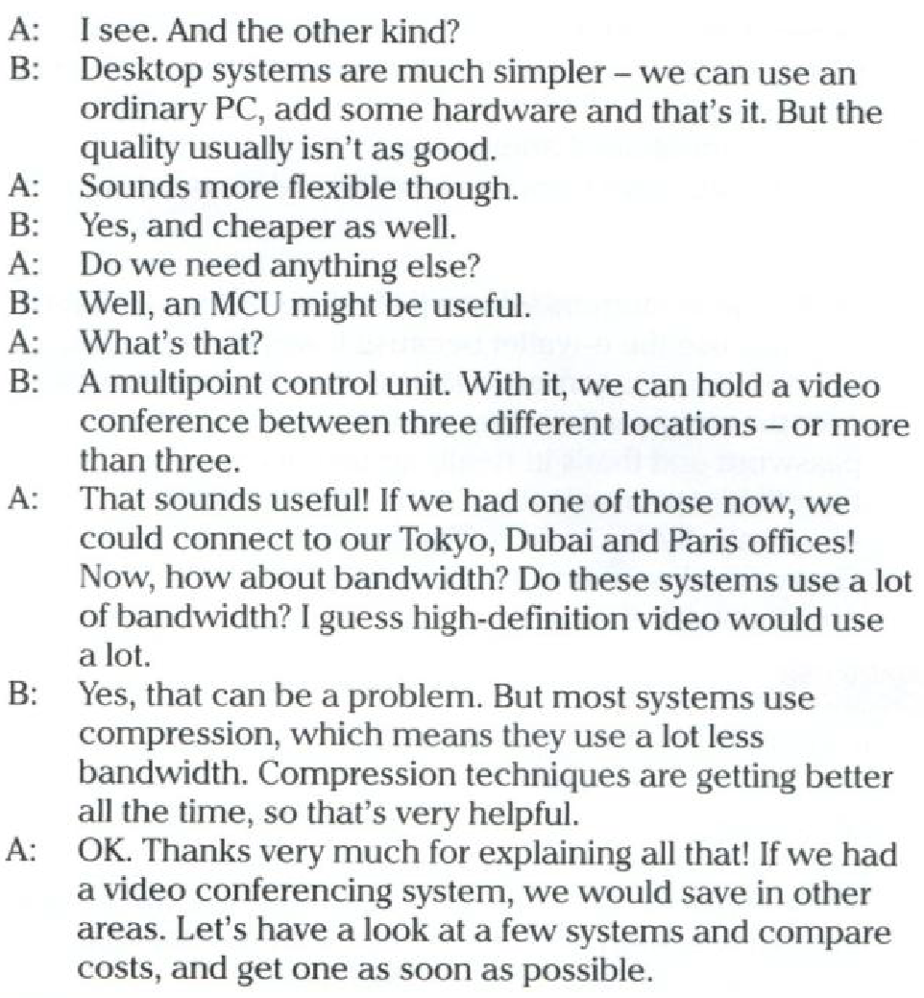

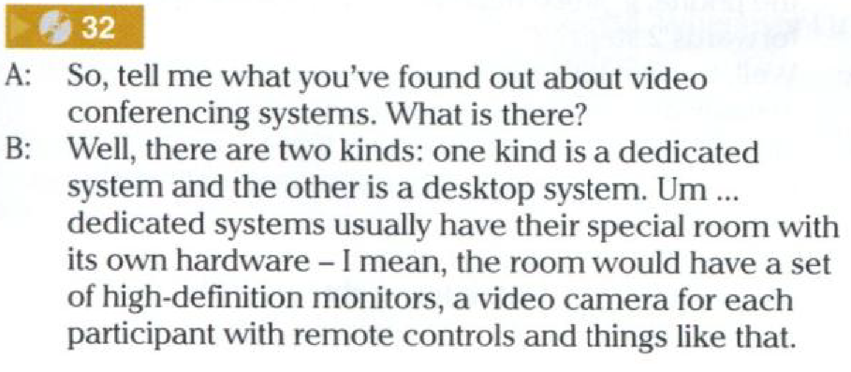

## LISTENING

**6.** [**Listen**](https://drive.google.com/file/d/1wha4uPolONk8MVUeh9DpxRZeswb13tX7/view?usp=sharing) **to five people talking about video conferencing. Do they think**

**the situation is likely or unlikely? Tick the correct column for each speaker.**

|  | Likely | Unlikely |
| --- | --- | --- |
| Speaker 1 |  |  |
| Speaker 2 |  |  |
| Speaker 3 |  |  |
| Speaker 4 |  |  |
| Speaker 5 |  |  |

**7. Work in pairs. Look at audio script 32 and complete this table. Then discuss the advantages and disadvantages of having each system.**

Example: *If we had a videophone, we could save a lot of money. But we wouldn't be able to have meetings with lots of people.*

|  | **Dedicated video conferencing system** | **Videophone** |
| --- | --- | --- |
| How many locations of participants? |  | *only two* |
| How many participants in each location? |  | *only one* |
| Cost? |  | *less expensive* |
| Room |  | *any room is OK* |
| Equipment needed |  | *only the videophone* |

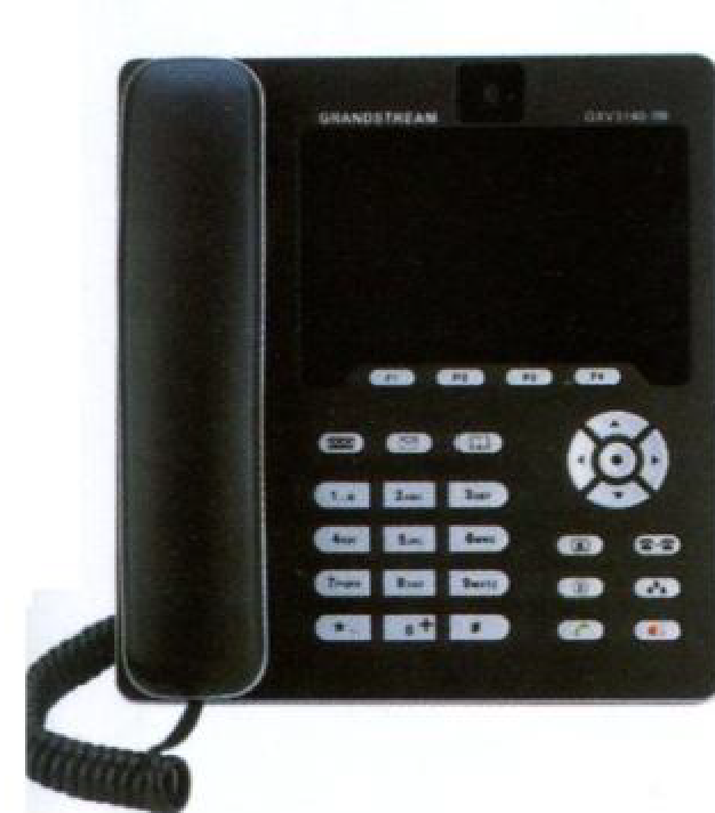

**8. Work in pairs. What would happen if you wanted a video conferencing system but didn't have these items? Complete this table. Then take turns to say complete sentences.**

| **Item** | **Problem without this item** |
| --- | --- |
| 1 encryption | *wouldn't be secure* |
| 2 warranty |  |
| 3 a high-speed internet connection |  |
| 4 anMCU |  |
| 5 training |  |
| 6 a dedicated room for the equipment |  |
| 7 data compression |  |

Example: *If we didn't have encryption, our video conferences wouldn’t be secure.*

1. **Work in pairs. Student A, you are a general manager. You want a video conferencing system but want to save money. Student B, try to persuade Student A, your manager, to have one of the features in 8. Then swap roles and repeat the activity.**
2. **If these people could use video conferencing facilities, how would their lives be different? Discuss. Use language from the Language box.**
3. a deaf person
4. a child who lives a long way from any school
5. doctors working in a small hospital a long way from a city
6. a company director who doesn't have time to visit her clients overseas

## GRAMMAR PRACTICE

**Complete the following sentences using the correct Conditional tense ( T2)**

* 1. If the new software was developed in Canada, the company (save) ……………………. US$59,000.
  2. There (be) ………………………….. any problems if they worked together.
  3. We would have a firm basis for believing that IOS passed the Kerkhoff’s test if it (be) …………… open source.
  4. If you (buy) …………………….. the latest software, you ( not- have) ………………. so many troubles.
  5. We wouldn’t be able to watch the movie if the computer program (be – not) ……………….. compatible.

For **extra practice**, go to the webpage below:

<https://www.liveworksheets.com/w/en/english-second-language-esl/44706>

# Class 5: TRADUCCIÓN DE ORACIONES CONDICIONALES TIPO 2

Hemos visto que las oraciones condicionales se utilizan para expresar situaciones que van desde hechos posibles, reales y hasta imaginarios. El sentido de cada oración varía dependiendo de los tiempos verbales que se utilicen.

En esta ocasión, nos vamos a enfocar en el Tipo 2.

En una oración condicional de tipo 2, el tiempo verbal de la cláusula "if" es el "simple past" y el de la proposición principal puede ser el "present conditional" o el "present continuous conditional".

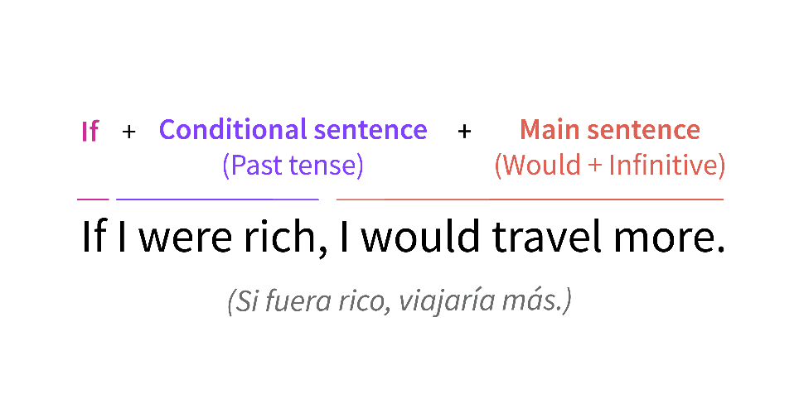

Como ocurre con todas las oraciones condicionales, el orden de las proposiciones no es fijo. Es posible que sea necesario modificar los pronombres y la puntuación al cambiar el orden de las cláusulas pero el significado de la oración sigue siendo el mismo.

Estas oraciones no aluden a una situación real. Este tipo de condicional describe *situaciones imaginarias o muy poco probables*. Dicho de otra manera, sirve para hablar de cosas improbables o casi imposibles.

Pensemos en este ejemplo. ¿Cómo podemos traducirlo?

* If the virus evolved, the firewall would be useless.

Este tipo de condicionales tiene la siguiente estructura:



El segundo condicional describe escenarios imaginarios hipotéticos. En general, se usa para plantear ideas irreales del presente o acciones en el futuro que resultan poco probables.

Esta estructura tiene dos usos en particular:

A- El primero es hablar de situaciones en el futuro que no es probable que ocurran, por ejemplo:

*If I won the lottery, I would spend my life travelling* (Si ganara la lotería, me pasaría la vida viajando).

En este sentido, las condicionales se utilizan para hablar de nuestros sueños, nuestros deseos, etc.

B- El segundo uso es para hablar de situaciones en el presente que no se pueden dar, porque son imposibles. Se verá mejor con un ejemplo:

*If I were younger, I would travel more* (Si fuera más joven, viajaría más).

¿Se entiende a qué nos referimos? Se trata de situaciones que no pueden ocurrir. Con ellas, intentamos expresar nuestro punto de vista sobre algo que ha ocurrido (o no), arrepentimientos, deseos o para dar consejos.

* Importante: A pesar de que se utilice el pasado simple, el segundo condicional no hace referencia al pasado. Se utiliza este tiempo verbal para indicar que es una acción irreal. Si quisiéramos hablar de condicionales pasados deberíamos utilizar el tercer condicional.

**Nota 1**: Con el verbo "to be", es correcto y además muy habitual decir "if I were" en lugar de "if I was".

Ejemplo: If I were you, I would give up smoking. (Si fuera vos, dejaría de fumar)

**Nota 2**: En las oraciones condicionales de tipo 2, también pueden emplearse los modales en la proposición principal para expresar el grado de certeza, permiso o una recomendación sobre el resultado.

Ejemplo: We might buy a larger house if we had more money. (Podríamos comprar una casa más grande si tuviéramos más dinero)

**Nota 3**: Igualmente, podemos emplear “unless” (que significa “if… not”) en la posición de “if”, pero recuerda que debes adecuar la frase a ese significado negativo que posee “unless”.

Por ejemplo:

-I wouldn’t go to that party unless you paid me (No iría a esa fiesta salvo que me pagaras).

Esa frase significa lo mismo que:

-I wouldn’t go to that party if you didn’t pay me (No iría a esa fiesta si no me pagaras).

En resumen:

Para hablar de situaciones reales en presente podemos emplear el condicional cero (refiriéndonos a hechos y cosas que son siempre ciertas) o el primer condicional (para hablar de cómo esas situaciones afectarán al futuro).

Podemos usar el segundo condicional para situaciones que no son reales (aunque quizá nos gustaría que lo fueran), y el tercero para imaginar cómo el pasado podría haber sido diferente.

Presta atención a la siguiente figura:

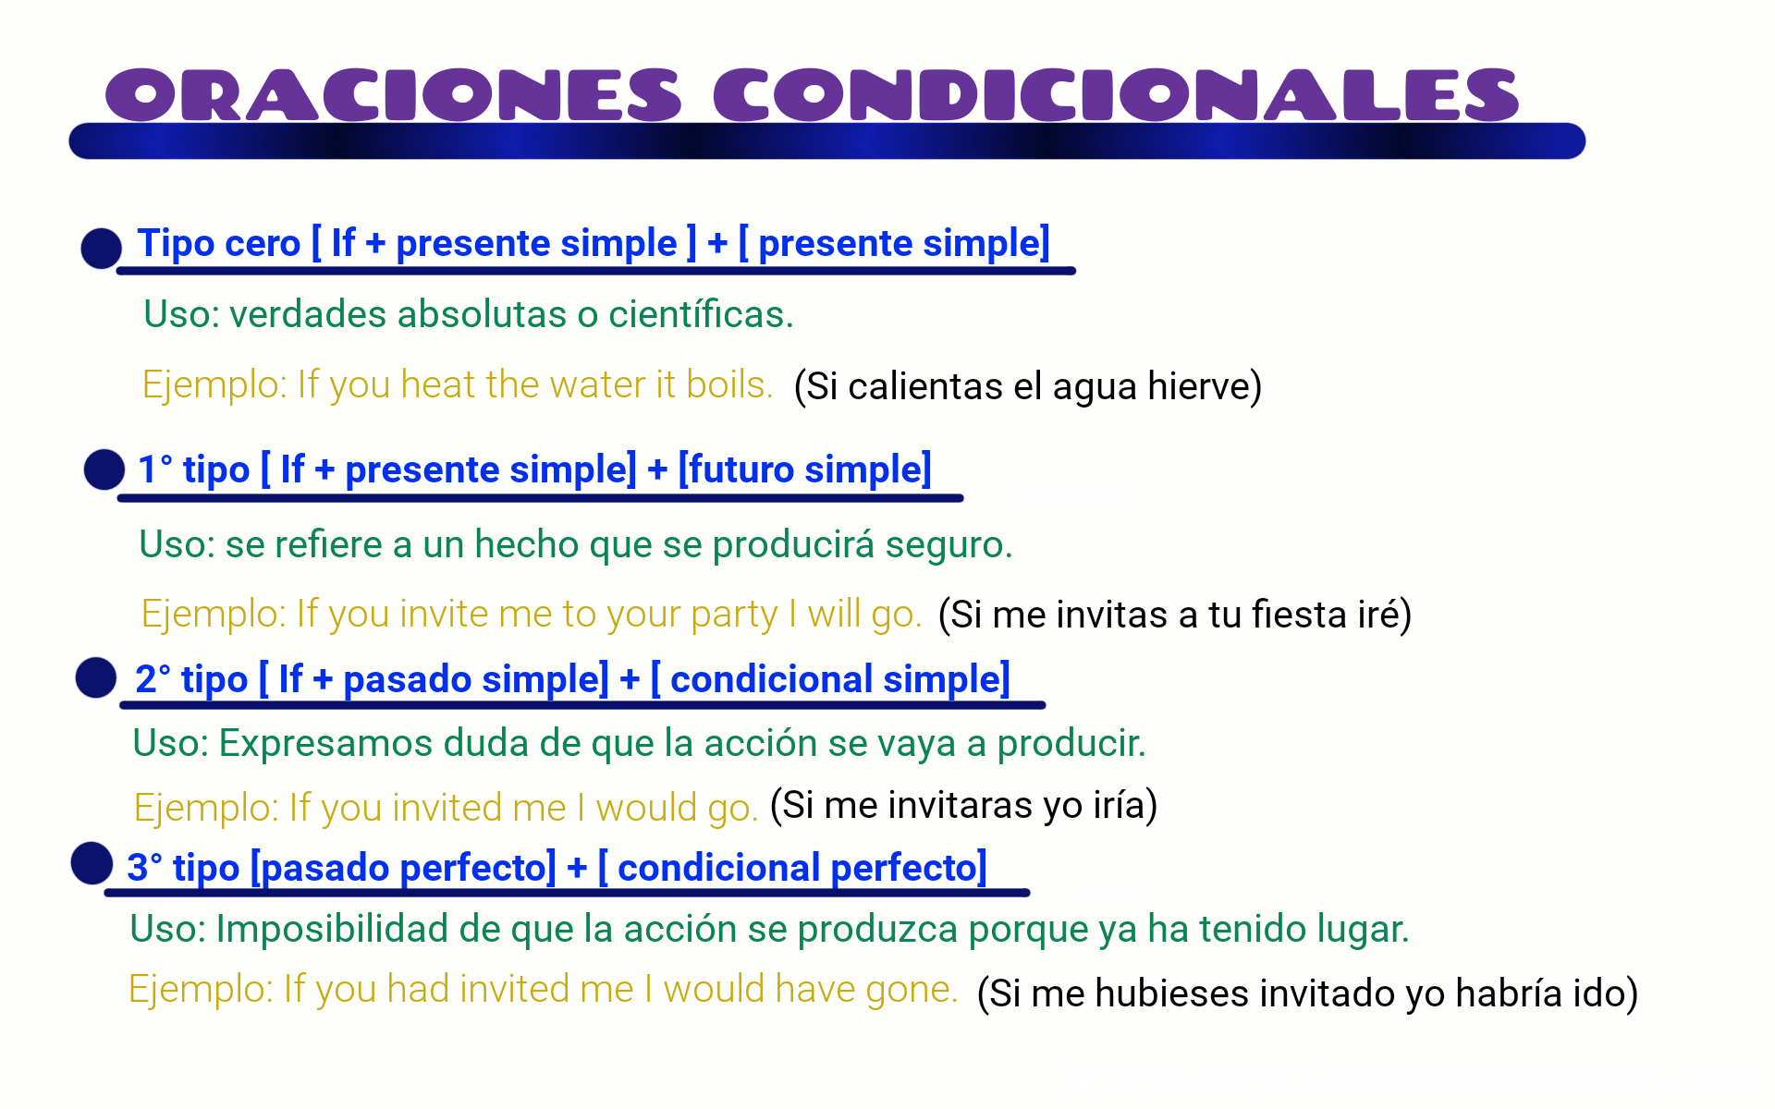

*¡Ahora es tu turno!*

## PrácticaPractice - Free education icons

**Traduce las siguientes oraciones.**

1. If you used antivirus software, the user interface (UI) of cloud antivirus software would look familiar.
2. The computer wouldn’t crash if the operator closed the critical file on time.
3. If malware was found in your computer, you would want to reset your account passwords.
4. If you were interested in data solutions, we would help you.
5. If you wanted to read about cloud solutions, you would be able to check our blog post.
6. Your computer would be faster if you had enough memory
7. If you wanted to create basic webpages, HTML would be the route to take.
8. You would feel more comfortable if you used wireless keyboards.
9. If you wondered where to start, this web site would answer all your questions.
10. If you understood the information above, then you should be ready to begin learning your first computer programming language.

Fuentes consultadas:

<https://www.britishcouncil.es/blog/segundo-condicional-ingles>

<https://www.ef.com.es/recursos-aprender-ingles/gramatica-inglesa/condicionales/>

<https://www.ef.com.ar/recursos-aprender-ingles/gramatica-inglesa/condicional-tipo-2/>

<https://www.ejerciciosinglesonline.com/blog/condicionales/>

<https://oxfordhousebcn.com/en/4-conditionals-in-english-and-when-to-use-them/>

<https://trucoslondres.com/aprender-ingles/gramatica/segundo-condicional-ingles/>

<https://whatsup.es/blog/aprende-por-fin-usar-condicionales-en-ingles>